Industrialization in the Indian Ocean: Brought and Exploited by European Imperialists
By: Regan Reed
Overview and Purpose:
Industrialization helped to change how people around the world traveled, traded, and interacted with one another. Although courses on industrialization normally focus on the Western World (such as the advent of the steam engine in Britain or the cotton gin in the United States), key aspects of how industrialization was introduced to the non-Western World and how it impacted non-Western populations is less understood. As one of the earliest epicenters for global trade, the Indian Ocean region (the coast of East Africa, the Arabian Peninsula, India, and the Spice Islands) has been an arena of technological and ideological exchange for millennia. The Industrial and Imperial Era (1170 CE to 1914 CE) saw historical trade routes exploited in new ways as imperialist nations, like the British, began to expand their global empires by creating colonies and spheres of influence around the world. These efforts would coincide with Europe’s industrial revolution in which new and exciting forms of technology were created to improve productivity and push the boundaries of travel. Through this lesson, students will learn to draw connections between imperialist powers creating spheres of influence in nations surrounding the Indian Ocean, the creation of port cities for international trade, and the spread of technologies created during the period of industrialization.

As they use the Industrial and Imperial Era map, students will be encouraged to think about why imperial powers found certain areas of the world to be important and why they brought these areas under their control. Through their exploration of the raw goods and materials which were important to the global system, students will learn that certain global commodities like cotton, vanilla, and chocolate could only be produced in specific climates. Due to the geographical limitations of these goods, imperial powers exerted their influence in these regions to ensure their control of these important commodities. By examining items like jute sacks and rubber plantations, students will see that European imperialists took advantage of cheap labor provided by the indigenous peoples living under their influence. Plantations for rubber, vanilla, chocolate, and other crops became popular in imperial hinterlands surrounding the Indian Ocean as controlling the land and means of production allowed Europeans to get the goods they wanted at a lower cost. Indigenous labor provided further reductions in price, which incentivized businessmen to bring industrial technologies to the Indian Ocean region and open mills and industrial factories.

Broadening their knowledge on the connections between industrialization in the Indian Ocean and the influence of imperialism will require students to look at cities that emerged during this period. Students will consider why these cities developed and what they offered to the global economic system. Imperial models of the period were not colony-focused; instead of dispatching large groups of Western officials to these locations, imperialist governments instead relied on local leaders to maintain order. These imperial western powers needed to create outposts to connect their holdings to global trade routes and by extension, their own rule. To do this, imperialist powers often created port cities, which acted as centers of trade and power. Port cities found on the Industrial and Imperial Era map like Hong Kong, Calcutta, and Bombay act as examples of imperialist outposts, which connected far flung locales to international markets. In many of these cities, wealthy businessmen from the controlling imperial power built cotton mills or other factories so they could exploit both cheap indigenous labor and the connection to international trade routes. Similar to their American and European counterparts, these port cities saw swells in population and growth as rural citizens sought new opportunities in these growing port cities.

Finally, students will look into new industrial technologies located on the Industrial and Imperial Era map, why they were brought to these regions, and how the technology affected indigenous peoples. Regardless of how certain technologies like railways, telegraph lines, and steam power would eventually benefit indigenous peoples, it is clear that these technologies along with others like the cotton spinning frame, were brought to imperial holdings specifically to benefit imperial powers and companies from these nations.

Intended Age Group:
Middle School World History Students, High School Students, AP World History Students.
Learning Objectives:
Through this lesson, students should:
- Be challenged to think critically and make connections between imperialism and the spread of industrialization in the Indian Ocean region.
- Determine what natural resources and raw materials were exported from lands surrounding the Indian Ocean specifically for the use of the imperialist powers.
- Understand that imperial powers were interested in areas of Africa, India, and Asia because they could exploit cheap labor and the natural resources that only grew in these areas.
- Recognize that many of important cities around the Indian Ocean today were created by imperialist powers as a means to connect their spheres of influence to the global marketplace.
Time:
This lesson should take 3 class periods of about 50 minutes each.
Materials Needed:
- Enough worksheets for all students in the class.
- A projector or smart board to watch clips as a class in Part I.
- Access to enough computers for students to complete Part II.
Procedure:
Part I
Teachers should give students a basic understanding of the Industrial Revolution in Europe and the technologies created by European nations. Some of these technologies will be found later in the lesson plan as important to the production of cheap goods in the Indian Ocean region. Additional resources on industrialization and imperialism can be found in the “historical overview” for the Industrial and Imperial Era (http://www.indianoceanhistory.org/assets/Site_18/files/Era%20Overviews/Industrial%20and%20Imperial%20Era.pdf) which can be assigned as take home (or in class) reading to prepare students for the lesson. Further, sections of John Green’s Crash Course History videos on imperialism (https://www.youtube.com/watch?v=alJaltUmrGo) and industrialization (https://www.youtube.com/watch?v=zhL5DCizj5c&t=374s) can be used to give a quick and fun in-class overview of both subjects. Encourage students to take notes during the videos as they could help to answer questions and make connections later on.
In their initial class, teachers should introduce the differences between colonizing powers and imperialists. Colonizers created settlements (colonies) that were intended to be populated by inhabitants of the motherland. Students should recognize the original thirteen colonies of the United States as an example of British settler colonialism. On the other hand, imperialists created spheres of influence, which were usually controlled and populated by indigenous peoples. This can be seen in India, where few British people actually lived and most of the people under the British control were actually indigenous Indian people.

Explain to students that there is overlap between colonialist and imperialist motivations. Both colonizers and imperialists wished to exploit the natural resources of the places they dominated. Often, although not always, colonizers pushed indigenous people off land to provide more space for colonizing populations and the freedom to create their own society. Conversely, imperialists often found ways of keeping existing power structures in place, requiring minimal European inhabitation while exerting maximum influence on the country. This allowed for Europeans to extract the goods that they wanted through deals with local heads of states without committing their own troops or administrators to run operations on the ground.
Teachers should also stress that industrialization led to new technologies that changed many aspects of how and where goods were produced and trade was located. Industrialization was sparked by businessmen looking for new ways to improve production and cut their costs. For some businessmen, their inventions were intended to increase production in their own factories and to undercut the prices of foreign products. However, when businessmen saw the potential to cut costs through cheap indigenous labor, they took inventions like the cotton spinning frame to imperialist outposts. The spread of industrial technologies to non-Western territories was also instituted by imperial governments who adopted technologies, like rail and telegraph lines, to make it easier to exert control over indigenous populations.
Europea involvement in the Indian Ocean region was largely necessitated by the geographical limitations for the production of goods like ivory, rubber, cotton, vanilla and chocolate. These geographical limitations led European powers to create new ways of maximizing the production of these commodities. New techniques to harvest and process goods, which were popular in Europe, like vanilla and chocolate, became important to imperial powers because of the lure of increased profits and the possibility of creating monopolies around specific in-demand commodities.
Lastly, teachers should ensure that students know that the industrial revolution introduced opportunities for improved travel, which allowed Western powers to dominate trade both on and off the seas. These technologies would include the Suez Canal, mechanical refrigeration, and railroads, which helped move people and products more efficiently from colonies and imperial holdings around the Indian Ocean to the Western World. These technologies were critical and worked in concert with efforts to extract raw materials and create goods throughout imperial hinterlands. These transportation technologies helped to quickly satisfy the demand for different goods in the Western World.
In presenting these ideas to students, the general questions asked later on in the lesson plan should be kept in mind. Frame discussion of these topics around how imperialism might be connected to industrialization in nations around the Indian Ocean. Also, remind students to be aware of why certain areas of the world were more important to imperialists than others, and to explore why these areas would become some of the major port cities that we know today.

Part II
Using the Industrial and Imperial Era Map (http://www.indianoceanhistory.org/LessonPlan/IndustrialandImperialEra.aspx) students will be asked to identify specific items from the Indian Ocean related to both industrialization and imperialism. These items include: industrial technologies created by Europeans, port cities established by imperialists, and raw goods, which were cultivated by imperialist powers for use in other regions of the world. These items are found in the charts below; they are intended to help highlight what aspects of the individual technologies, ports, and goods students should be focusing on in their examination. This includes which foreign forces influenced different port cities, what technologies could be specifically used for, and where goods produced in spheres of influence would eventually end up.
Teachers should have students work in small teams in computer labs to fill out the worksheets (provided at bottom of lesson plan) with these details. Remind students to think critically about why these items are important to both industrialization and imperialism and how they may be linked to the items found being found by other groups. Encourage students to think about how their specific items can fit into the larger picture of industrialization and imperialism in the world.

Part III
Have students present their findings to the rest of the class. Students who are listening should be expected to fill out their own copy of the sheets with the missing information. During or after the presentation of the material found by students, the class should discuss how all three sections are connected. Further, the overall importance of both industrialization and imperialism in the Indian Ocean region should be discussed. Finally, have students reflect on how they think industrialization is linked directly to imperialism. To either help guide the discussion or evaluate if students have learned the material, use the “Making Connections” worksheet located at the end of the lesson plan.

Worksheets:
Located on Next Page

Name: ________
Date: ________
Period: ________

Industrial Era Technologies
 | Where was it invented? | Where is it being used? | What is it being used for? | Why is it important?
Cotton Spinning Frame
Gatlin Gun
Railways (E. African & Indian)
Suez Canal
Steam Power
Indo-European Telegraph Line
Mechanical Refrigeration
Port Cities
 | Where is the port located? (Country) | Is there foreign influence over the port? If so, who? | What industries or goods are produced there? | Place a mark on the map where the port is located.
Hong Kong
Bombay
French Indo-China
Zanzibar
Calcutta
Aceh
Batavia

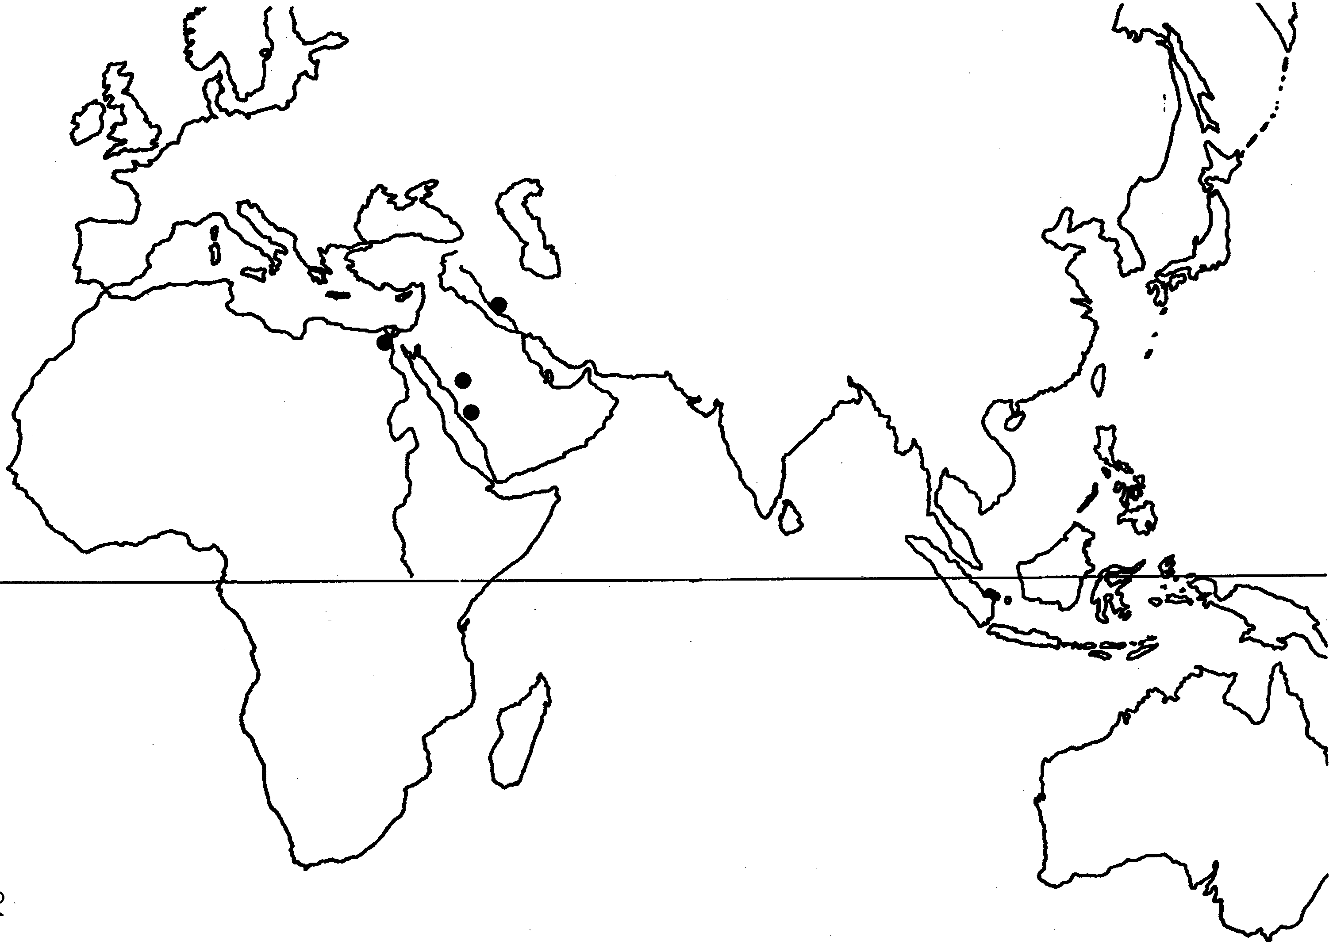

Found at: https://www.thinglink.com/scene/578665304947687424

Raw Materials and Goods
 | Is the item a raw material or finished good? Or both? | Where was it produced? | Where is the good going to end up? | Why is this item valuable? What is it used for?
Ebony & Teak Wood
Cotton Calico
Rubber
Jute Sacks
Vanilla
Commercial Whaling
Chocolate

Name: ___________
Date: ___________
Period: ___________
Making Connections:
Now that you have had a chance to look at port cities around the Indian Ocean, industrial technologies, and raw materials and goods, answer the following questions:
- Where were European imperialists interested in creating ports? Why do you think they were interested in these areas? Why not other areas? Were there specific benefits to placing ports in one area instead of another? Explain.

- What types of technology were introduced to the Indian Ocean region? Why do you think that Europeans introduced these specific technologies? Did these technologies benefit the indigenous peoples? The imperialist powers? Both? Explain.

- What materials and goods were important to trade in the Indian Ocean between 1770 and 1940? Do you think that certain goods became more or less important during this period? If so, which ones and why? Were these goods raw materials? Were they finished products? What uses did these good have in areas other than the Indian Ocean that were important to imperial powers? Explain.

- Overall, explain how you think ports around the Indian Ocean, technology, and raw materials all fit together; try to use specific examples from your worksheets. In your response, address how you believe that these connections were either created by imperialist powers or exploited by them.

